DATE | 10-11-2022
TEAM ID | PNT2022TMID31844
PROJECT NAME | Intelligent Specific fire Management System

WOKWI WEB URL:
https://wokwi.com/projects/347902799903720019

Snapshots of Simulation:

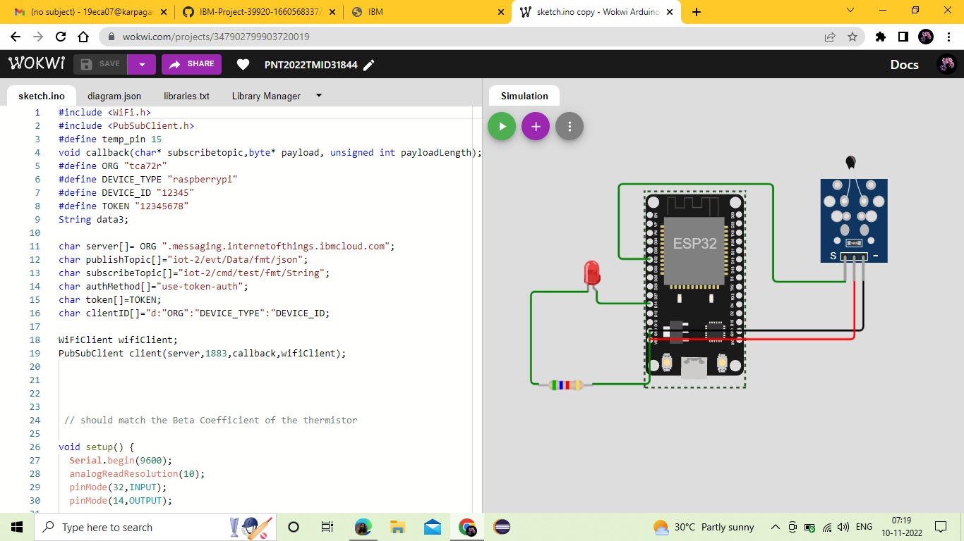
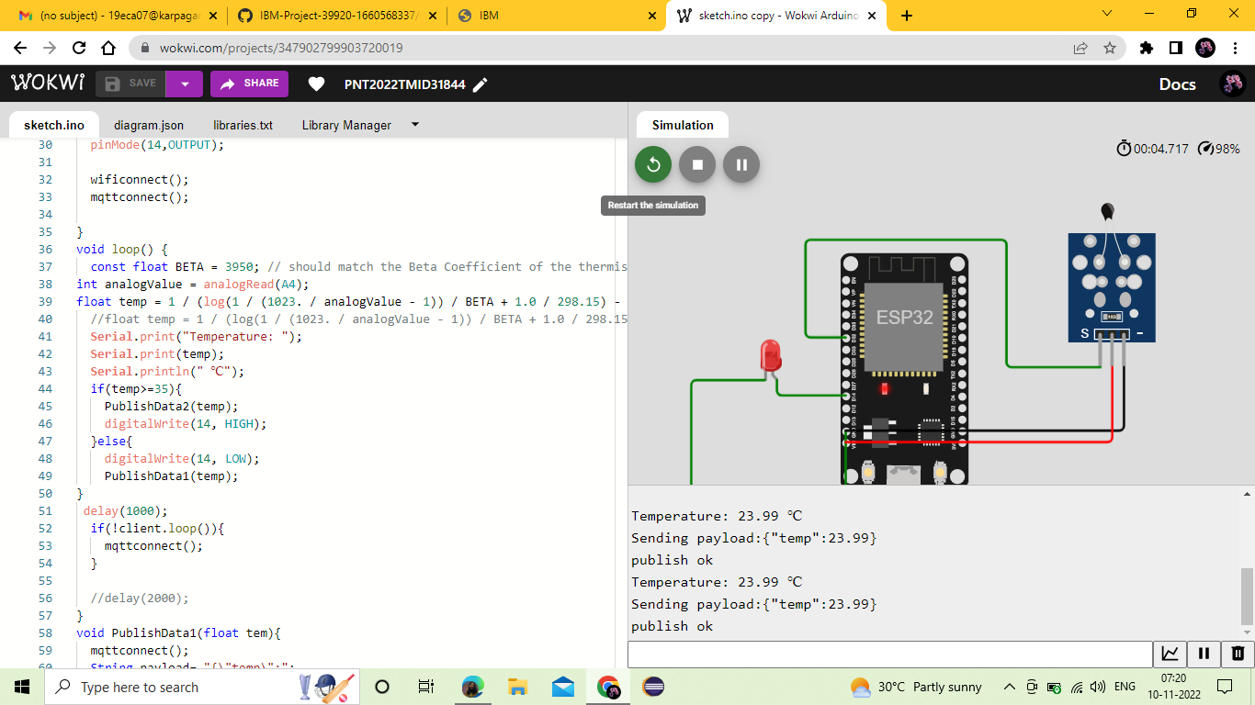

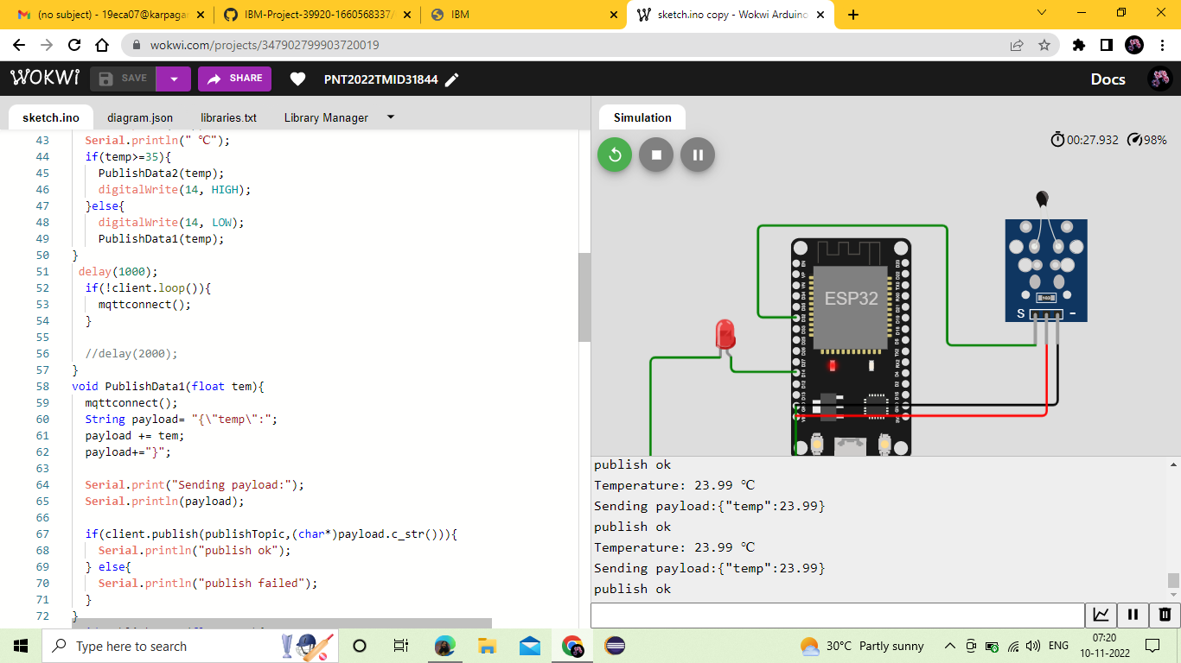

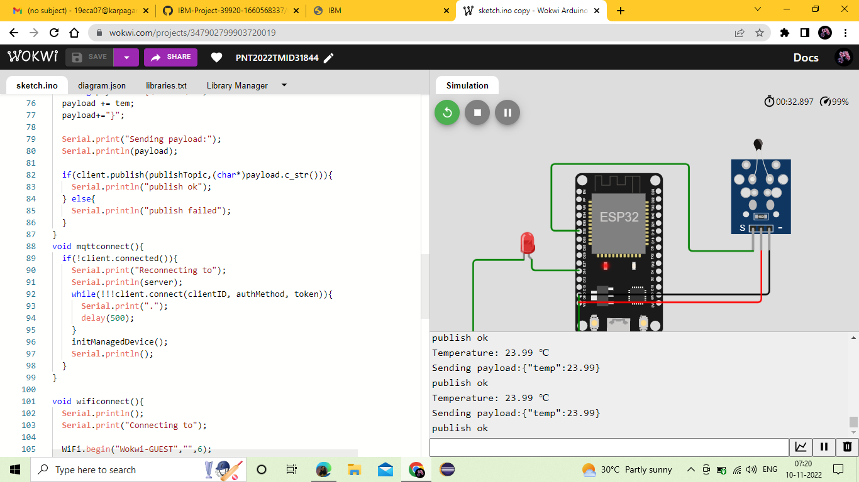

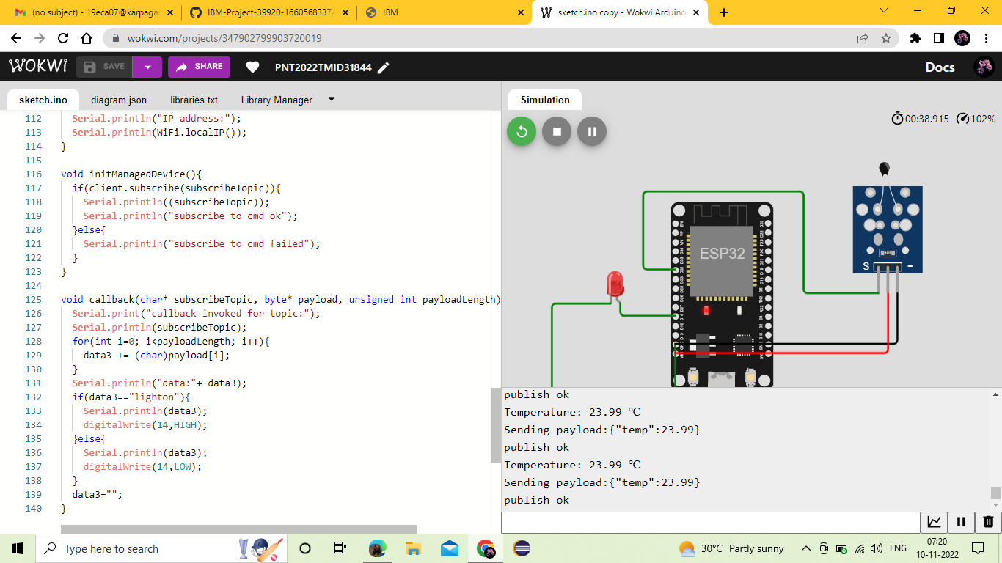

Data in IBM CLOUD:

